Supplemental Results

Table 1S. Supplemental analysis of field specimens.

A: Anova of standard length of field specimens
Source | DF | SS | F | Prob > F
Population[Drainage] | 5 | 0.52 | 1.45 | 0.2067
Drainage | 3 | 1.3 | 6.03 | 0.0006
Error | 195 | 14.05 | 0.072
B: Anova of Absolute Eye Size of field specimens
Source | DF | SS | F | Prob > F
Population[Drainage] | 5 | 74.4 | 1.49 | 0.1941
Drainage | 3 | 108.7 | 3.63 | 0.0139
Error | 195 | 1946 | 9.98
C: Ancova of Absolute Eye Size with Standard Length
Source | DF | SS | F | Prob > F
Standard Length (SL) | 1 | 9.125 | 702 | <0.0001
Population[Drainage] | 6 | 1.098 | 14.1 | <0.0001
Drainage | 2 | 0.731 | 28.1 | <0.0001
SL*Population*[Drainage] | 6 | 0.0424 | 0.544 | 0.774
Drainage*SL | 2 | 0.0292 | 1.12 | 0.327
Error | 186 | 2.42 | 0.013
D: Anova of Relative Eye Size (Presented in main manuscript)
Source | DF | SS | F | Prob > F
Drainage | 3 | 1.51 | 38.72 | <0.0001
Population[Drainage] | 5 | 0.63 | 9.71 | <0.0001
Error | 195 | 2.53

Table 2S. Supplemental Analysis of Laboratory Cross Specimens.

A: Anova of standard length
Source | DF | SS | F | Prob > F
Parent | 4 | 1339.7946 | 96.1037 | <0.0001
Rearing Environment (RE) | 1 | 11.6012 | 3.3286 | 0.0691
RE*Parent | 4 | 592.1122 | 42.4723 | <0.0001
Error | 301 | 1049
B: Anova of absolute eye size
Source | DF | SS | F | Prob > F
Parent | 4 | 4.93 | 65.26 | <0.0001
Rearing Environment (RE) | 1 | 0.01 | 0.77 | 0.38
RE*Parent | 4 | 1.68 | 22.20 | <0.0001
Error | 301 | 5.68
C: Reduced analysis of covariance of absolute eye size with standard length as a covariate. Interactions with fixed effects are dropped
Source | DF | SS | F Ratio | Prob > F
SL | 1 | 3.90 | 655.05 | <0.0001
Parent | 4 | 0.36 | 14.96 | <0.0001
Rearing Environment (RE) | 1 | 0.11 | 17.92 | <0.0001
Parent*RE | 4 | 0.05 | 2.14 | 0.076
Error | 300 | 1.78
D: Full analysis of covariance on absolute eye size with standard length as a covariate. All interactions are included.
Source | DF | SS | F | Prob > F
SL | 1 | 2.06 | 366.25 | <0.0001
Parent | 4 | 0.31 | 13.60 | <0.0001
Rearing Environment (RE) | 1 | 0.00 | 0.21 | 0.649
Parent*RE | 4 | 0.07 | 2.92 | 0.022
Parent*SL | 4 | 0.06 | 2.62 | 0.035
RE*SL | 1 | 0.00 | 0.83 | 0.363
Parent*RE*SL | 4 | 0.05 | 2.43 | 0.048
Error | 291 | 1.64
E: Mixed model on relative eye size with parent pair and the interaction between parent pair and rearing environment treated as a random effect (presented in the main manuscript)
Source | Num DF | Den Def | F | Prob > F
Rearing Environment (RE) | 1 | 3.93 | 10.58 | 0.0321

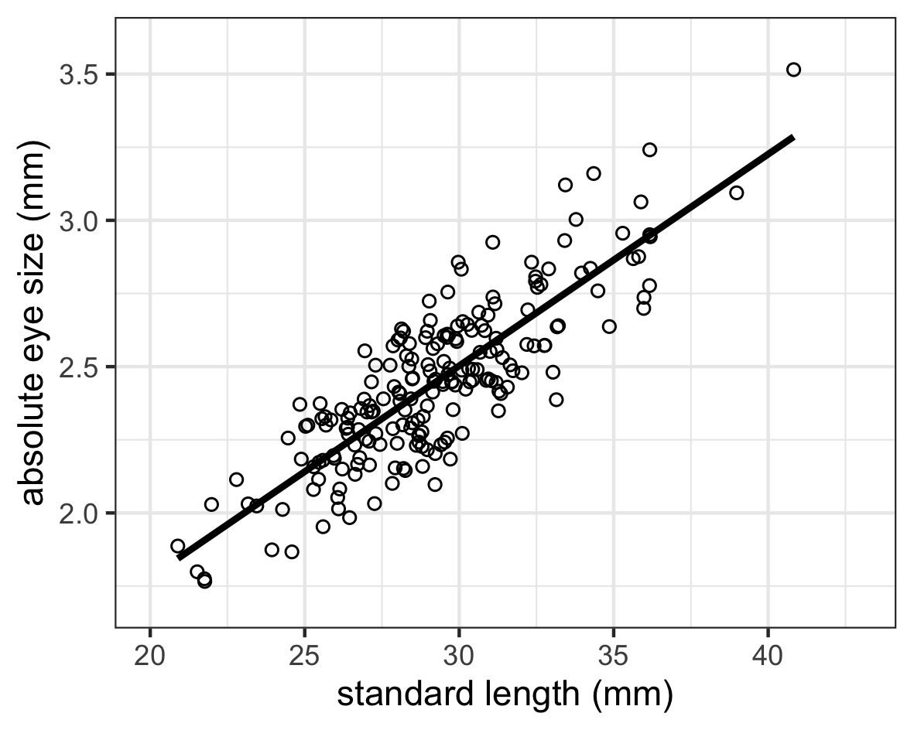
Fig. 1S. Linear relationship between standard length and absolute eye size from field samples.

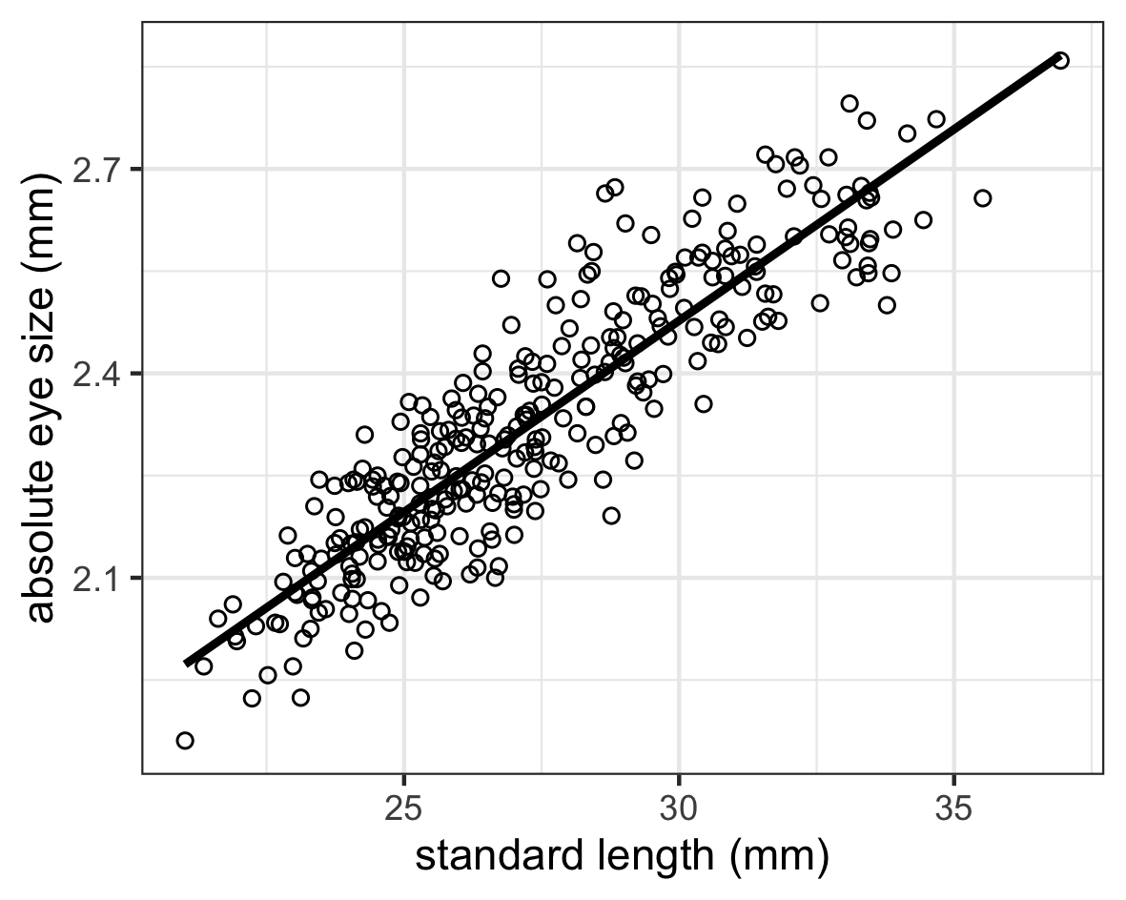

Fig. 2S. Linear relationship between standard length and absolute eye size from field samples.

