Supplemental Appendix C for ‘Museum specimens reveal life history variation in Plethodon montanus’ by Caruso and Rissler.
-Nicholas M Caruso -Leslie J. Rissler
9 August 2019

Growth model traceplots
Figure S1
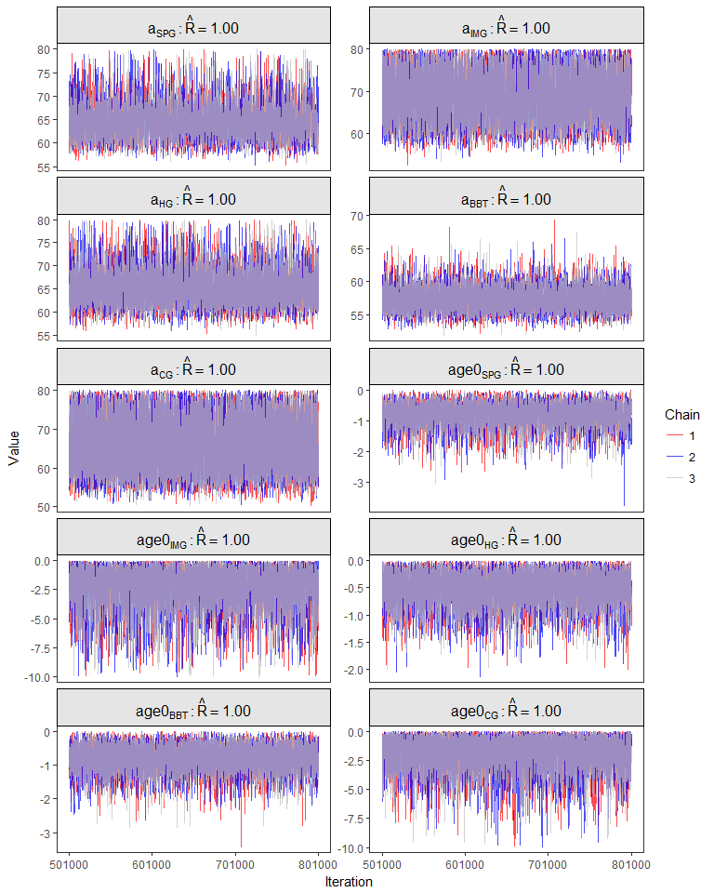
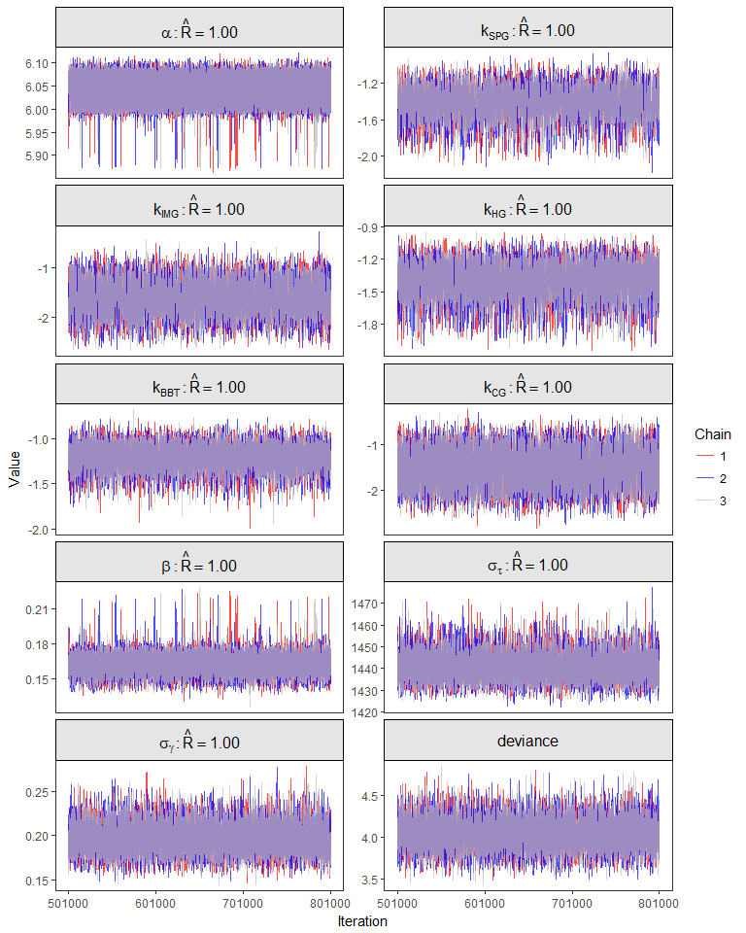

Department of Fish and Wildlife Conservation, Virginia Polytechnic Institute and State University College of Natural Resources, Blacksburg, VA 24061; carusonm@gmail.com
Division of Environmental Biology, National Science Foundation, Alexandria, VA 22314, USA

