Supplemental Appendix A for ‘Museum specimens reveal life history variation in Plethodon montanus’ by Caruso and Rissler.
-Nicholas M. Caruso -Leslie J. Rissler
9 August 2019
Fig. S1: Location of museum specimens within the range of Plethodon montanus. Inset map shows the location of P. montanus’ range in the Eastern United States.
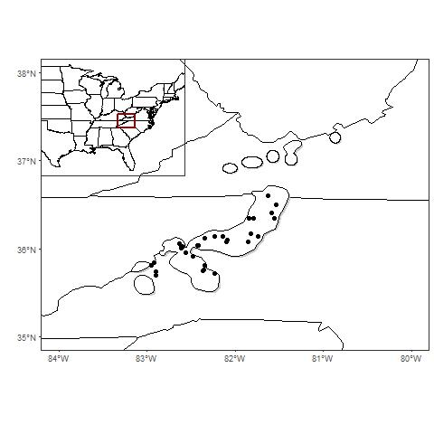

Table S2: Minimum, median, and maximum for the explanatory variables used to model reproduction and maturation of P. montanus across its range. Climate variables were extracted for each geographic location using the WORLDCLIM database (Hijmans et al., 2005).
Variable | Min | Median | Max
Latitude | 35.6978 | 36.0363 | 36.5956
Elevation (m) | 912 | 1141 | 1467
Annual Average Temperature (ºC) | 8.2 | 9.8 | 10.9
Temperature Seasonality  (Standard deviation*100) | 6917 | 7067.5 | 7262
Annual Precipitation (mm) | 1242 | 1418 | 1601
Precipitation Seasonality  (Coefficient of Variation) | 9 | 10 | 12

Fig. S2 Examples of femur cross sections for a) one-, b) three-, c) eight-, and d) five-year old salamanders; a) and b) show no signs of endosteal bone remodeling. All images were taken with the same total magnification (100x) and the scale bar shows 10μm.
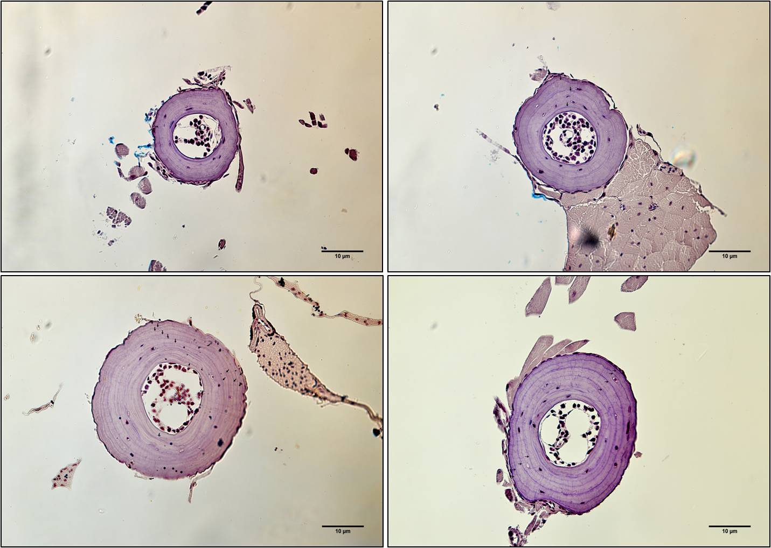
b)
c)
d)
a)

Table S2: Sample sizes for lost LAG and growth portions of the skeletochronology model.
Site | Lost LAGs | Growth
 |  | JUV | M | F
SPG | 6 | 10 | 31 | 40
IMG | 5 | — | 9 | 9
HG | 32 | 12 | 24 | 30
BBT | 33 | 12 | 30 | 47
CG | — | 1 | 5 | 2

Department of Fish and Wildlife Conservation, Virginia Polytechnic Institute and State University College of Natural Resources, Blacksburg, VA 24061; carusonm@gmail.com
Directorate for Biological Sciences, National Science Foundation, 4201 Wilson Blvd. Arlington, VA 22230, USA

