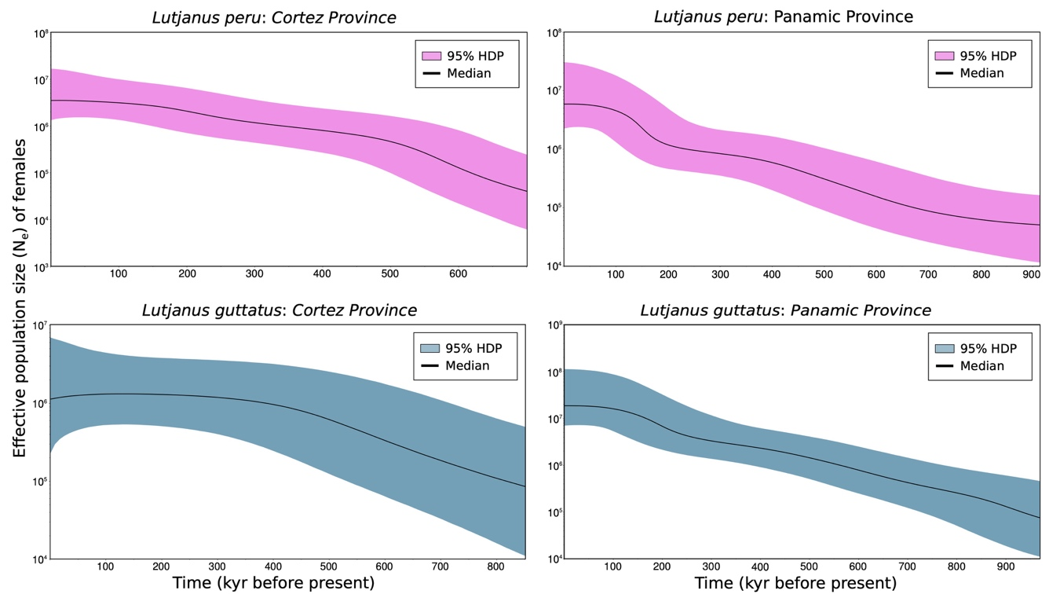

Bayesian Skyline Plots per biogeographic province according to Robertson and Cramer (2009). Shaded area represents 95% confidence interval.

