**Supplemental Figures A – E** for “Redescription and Recognition of *Etheostoma cyanorum* from Blue River, Oklahoma”, Matthews and Turner

**Supplemental Figure A**: Method for measurement of Angle of Anterior Profile (AAP), for large (60 mm SL) and average sized (47 mm SL) adult male *E. cyanorum* from Blue River.



**Supplemental Figure B**: Male *Etheostoma cyanorum*, sampled August 2017 in upper Blue River, selected by a “neutral observer” as “least rounded” (left side of figure; SL top to bottom = 49, 47, 48 mm) versus “most rounded” (right side of figure; SL top to bottom = 60, 53, 58 mm).



**Supplemental Figure C:** For male *Etheostoma cyanorum*, trait size versus standard length for snout length, body depth, and caudal peduncle depth, in parts per thousand of standard length.

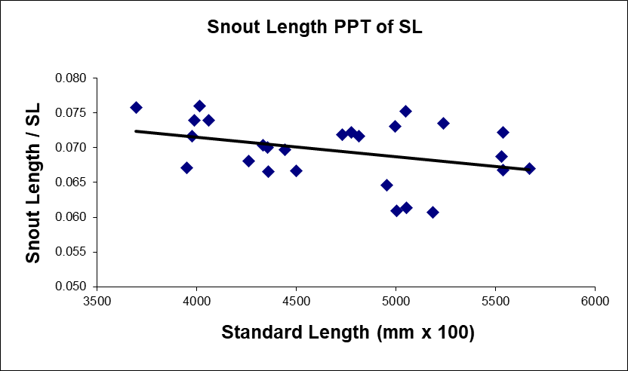

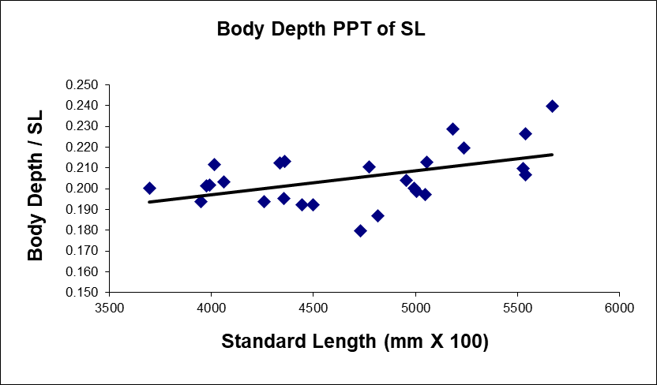

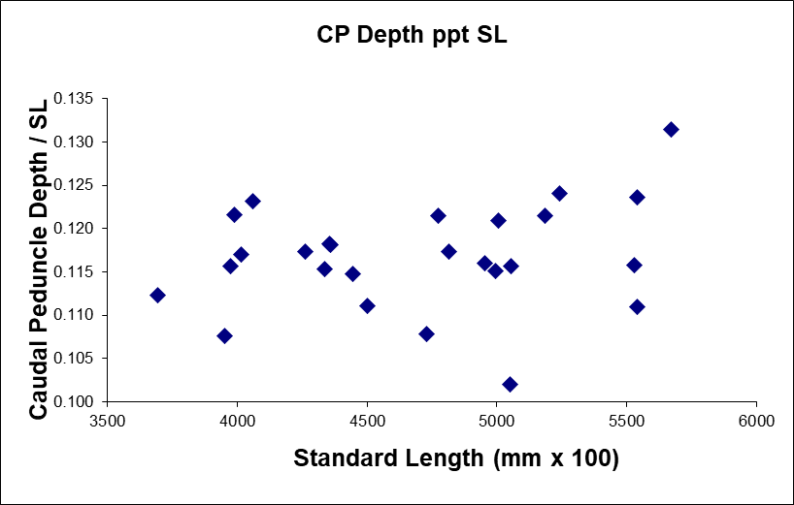

**Supplemental Figure D**: Meristics (a) Unpored lateral line scales and (b) pored lateral line scales means (solid dot) +/- 2 standard errors for *E. cyanorum* (Population 1) and *E. radiosum* populations numbered from drainages west to east as follows: Washita (2), Clear Boggy (3), Muddy Boggy (4), Kiamichi (5),Little (6), Glover (7), Mountain Fork (8), Rolling Fork (9), Cossatot (10), Saline (11), upper Ouachita (12), Caddo (13), Little Missouri (14).

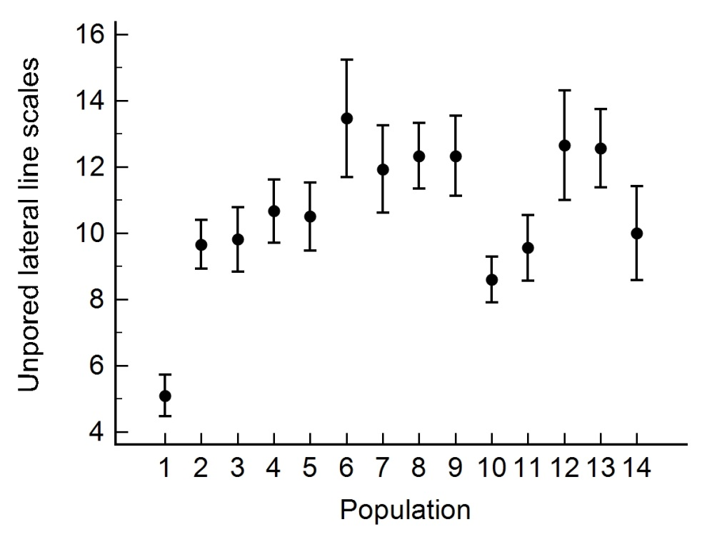

**a**

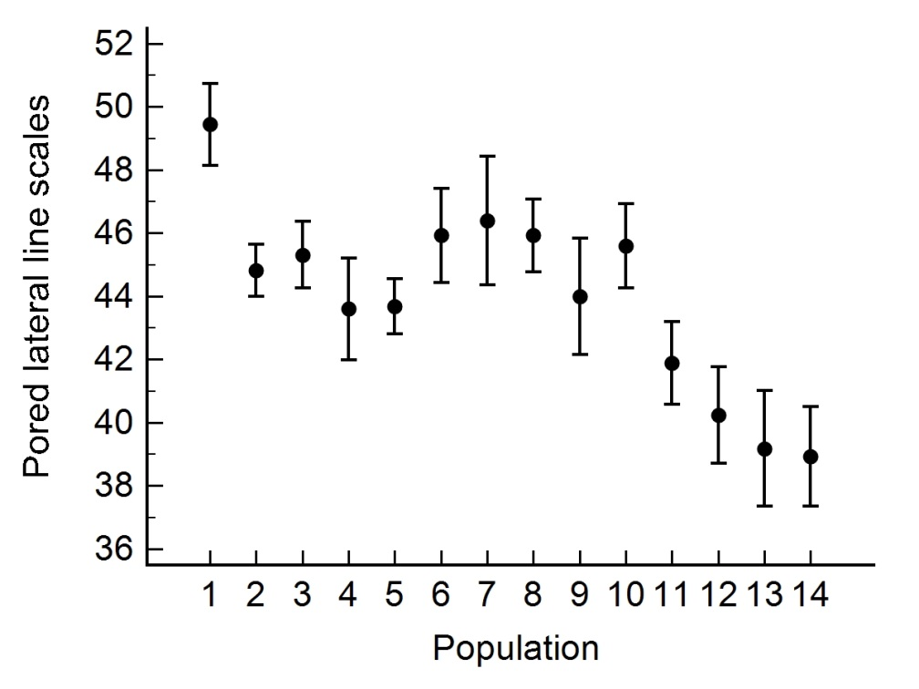

**b**

**Supplemental Figure E**: (a) interorbital width, (b) head depth, (c) head width, and (d) body depth means (solid dot) +/- 2 standard errors for *E. cyanorum* (Population 1) and *E. radiosum* populations numbered from drainages west to east as follows: Washita (2), Clear Boggy (3), Muddy Boggy (4), Kiamichi (5),Little (6), Glover (7), Mountain Fork (8), Rolling Fork (9), Cossatot (10), Saline (11), upper Ouachita (12), Caddo (13), Little Missouri (14).

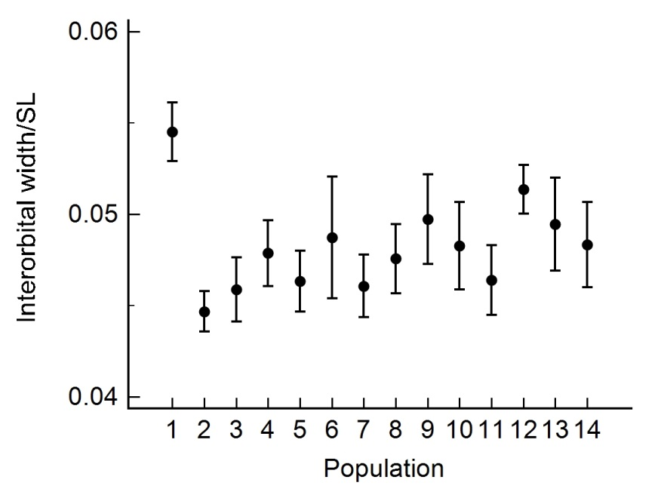

**a**

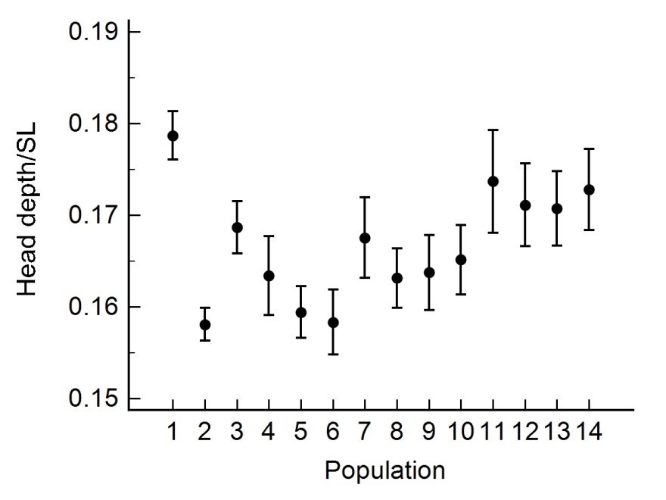

**b**

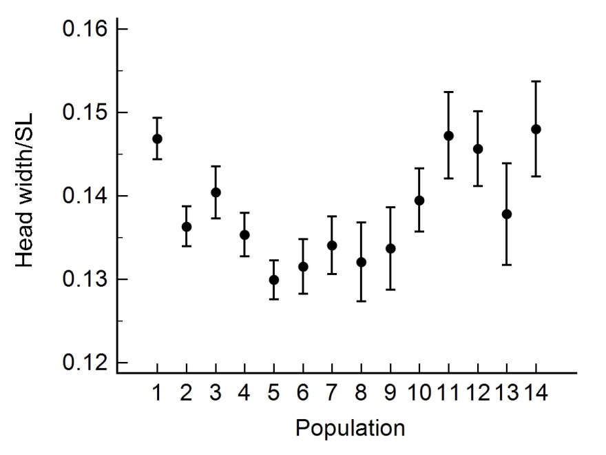

**c**

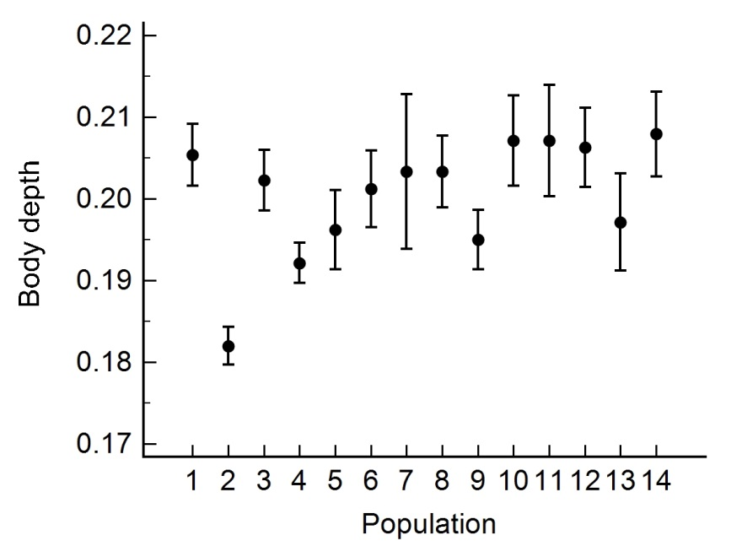

**d**