Appendix 2: Principal Components Analysis of Final Time-point
From Copeia manuscript “Warming Strengthens the Ecological Role of Intraspecific Variation in a Predator”
David C. Fryxell and Eric P. Palkovacs
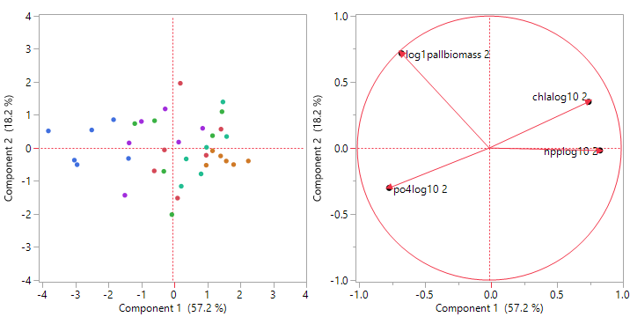
Fig C1: Principal components of all treatments (blue= unwarmed fishless, red= unwarmed cool source, green= unwarmed warm source, purple= warmed fishless, orange= warmed cool source, teal= warmed warm source) on correlations of all four log transformed ecological response variables four weeks after fish introduction. “Allbiomass” is crustacean zooplankton biomass. “Chla” is phytoplankton abundance (i.e. chlorophyll a concentration). “Po4” is phosphate concentration. “Npp” is net primary productivity.

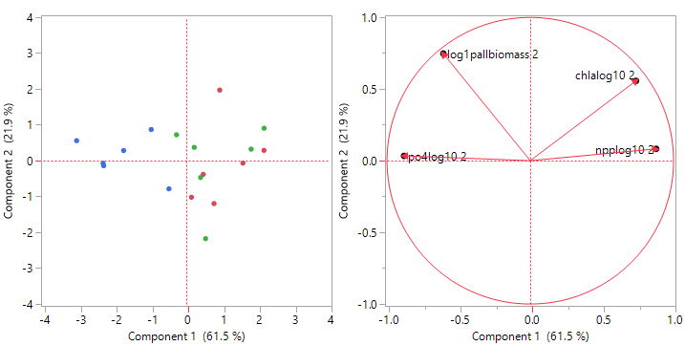
Fig C2: Principal components of unwarmed treatments only (blue= fishless, red= cool source, green= warm source) on correlations of all four log transformed ecological response variables four weeks after fish introduction. “Allbiomass” is crustacean zooplankton biomass. “Chla” is phytoplankton abundance (i.e. chlorophyll a concentration). “Po4” is phosphate concentration. “Npp” is net primary productivity.

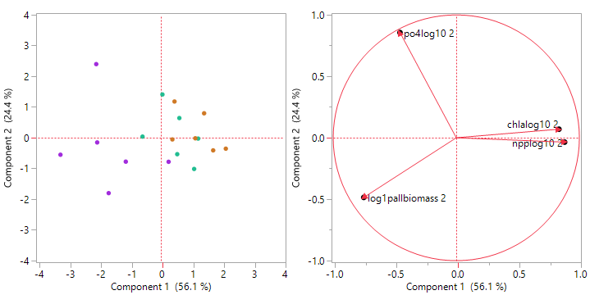
Fig C3: Principal components of warmed treatments only (purple= fishless, orange= cool source, teal= warm source) on correlations of all four log transformed ecological response variables four weeks after fish introduction. “Allbiomass” is crustacean zooplankton biomass. “Chla” is phytoplankton abundance (i.e. chlorophyll a concentration). “Po4” is phosphate concentration. “Npp” is net primary productivity.

